Binomial Expansion- Questions
May 2016 Mathematics Advanced Paper 1: Pure Mathematics 2

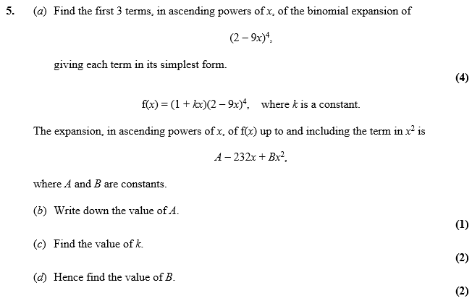

May 2014 Mathematics Advanced Paper 1: Pure Mathematics 2

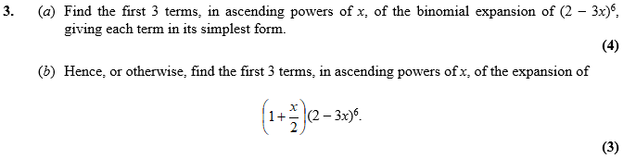

May 2013 Mathematics Advanced Paper 1: Pure Mathematics 2

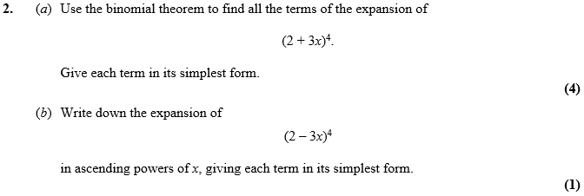

Jan 2012 Mathematics Advanced Paper 1: Pure Mathematics 2

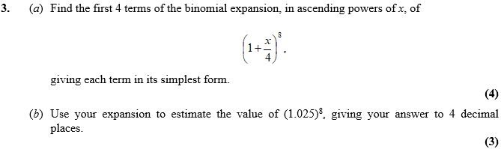

May 2011 Mathematics Advanced Paper 1: Pure Mathematics 2

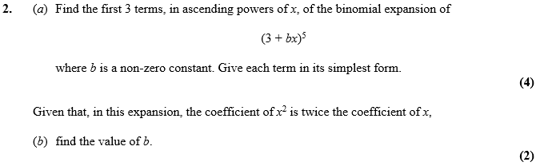

Jan 2011 Mathematics Advanced Paper 1: Pure Mathematics 2

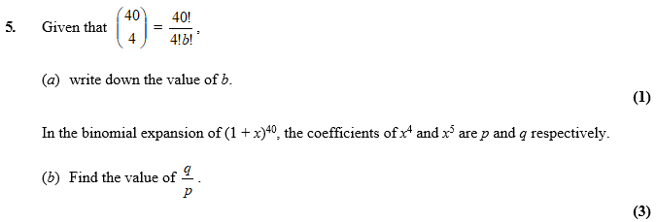

Jun 2010 Mathematics Advanced Paper 1: Pure Mathematics 2

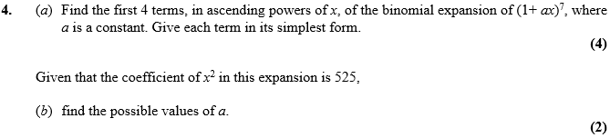

June 2017 Mathematics Advanced Paper 1: Pure Mathematics 4

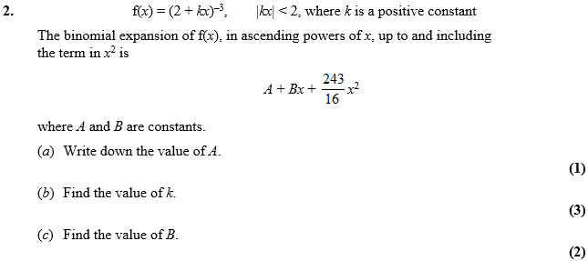
June 2016 Mathematics Advanced Paper 1: Pure Mathematics 4

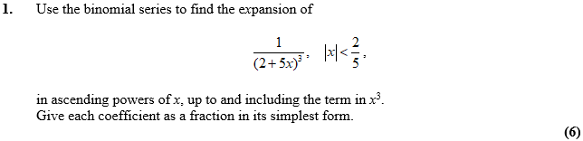

June 2015 Mathematics Advanced Paper 1: Pure Mathematics 4

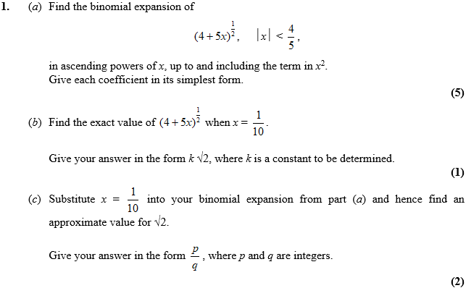

June 2014 Mathematics Advanced Paper 1: Pure Mathematics 4

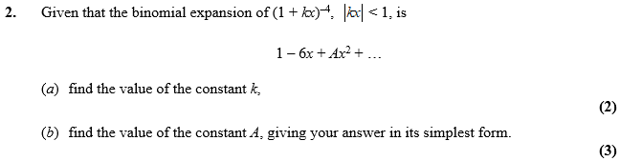

June 2013 Mathematics Advanced Paper 1: Pure Mathematics 4

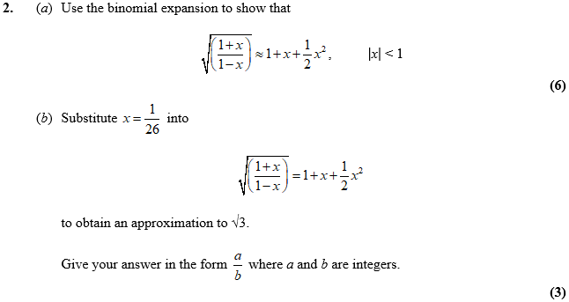

Jan 2013 Mathematics Advanced Paper 1: Pure Mathematics 4

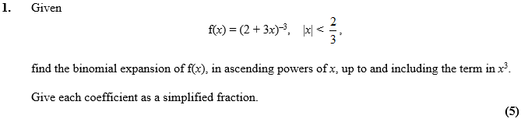
June 2012 Mathematics Advanced Paper 1: Pure Mathematics 4

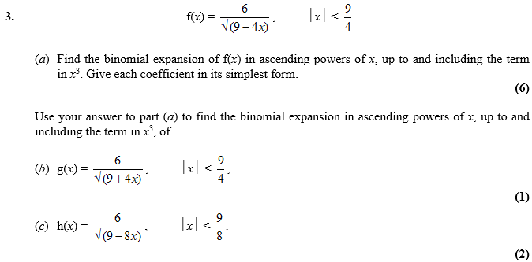

Jan 2012 Mathematics Advanced Paper 1: Pure Mathematics 4

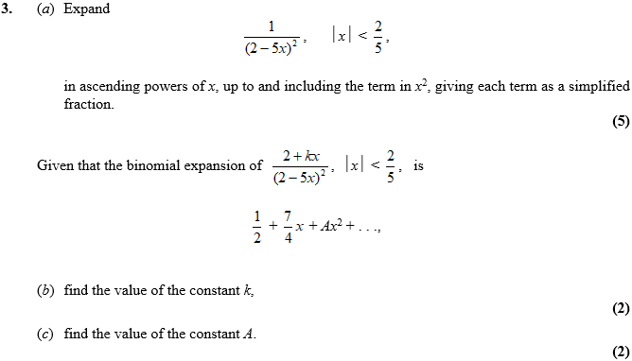

June 2011 Mathematics Advanced Paper 1: Pure Mathematics 4

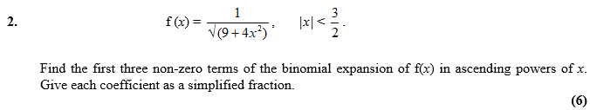

Jan 2011 Mathematics Advanced Paper 1: Pure Mathematics 4

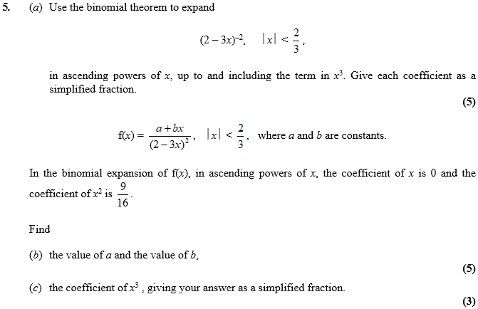

Jan 2010 Mathematics Advanced Paper 1: Pure Mathematics 4

